1. Labeled Diagram of an ATX Motherboard:
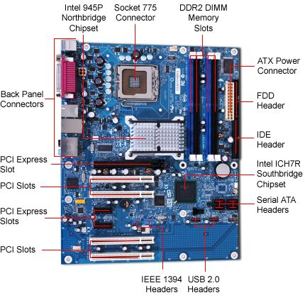

2. Popular CPU Socket Types:
A CPU socket is the physical connector on a motherboard where the processor is installed. Different CPUs require specific socket types.

No. | CPU Socket Type | Compatible CPU Model
1 | LGA 1151 | Intel Core i7-9700K
2 | AM4 | AMD Ryzen 5 3600
3 | LGA 1200 | Intel Core i5-10400

Note: CPU compatibility also depends on the motherboard chipset and BIOS/UEFI support.

3. Functions of CPU and Chipset:
CPU (Central Processing Unit):
The CPU is the main processing unit of a computer. It executes instructions, performs calculations, processes data, and controls many operations of the system.
Chipset:
The chipset manages communication between the CPU and various hardware components connected to the motherboard. It helps control devices such as USB, storage, and expansion devices. In modern computers, some functions that were traditionally handled by the chipset are built directly into the CPU.
Example: Opening Spotify
When we open a music application such as Spotify, the following process takes place:
- We click the Spotify application.
- The CPU processes the instructions needed to start the application.
- The required files are loaded from the SSD or HDD.
- The application is loaded into RAM for faster access.
- The CPU processes Spotify’s instructions and data.
- Motherboard controllers help manage communication with connected hardware.
- The processed audio data is sent to the audio hardware, and we hear the music through speakers or headphones.
In Simple Words:
CPU = Processes instructions and data
Chipset = Helps manage communication between the CPU and motherboard devices
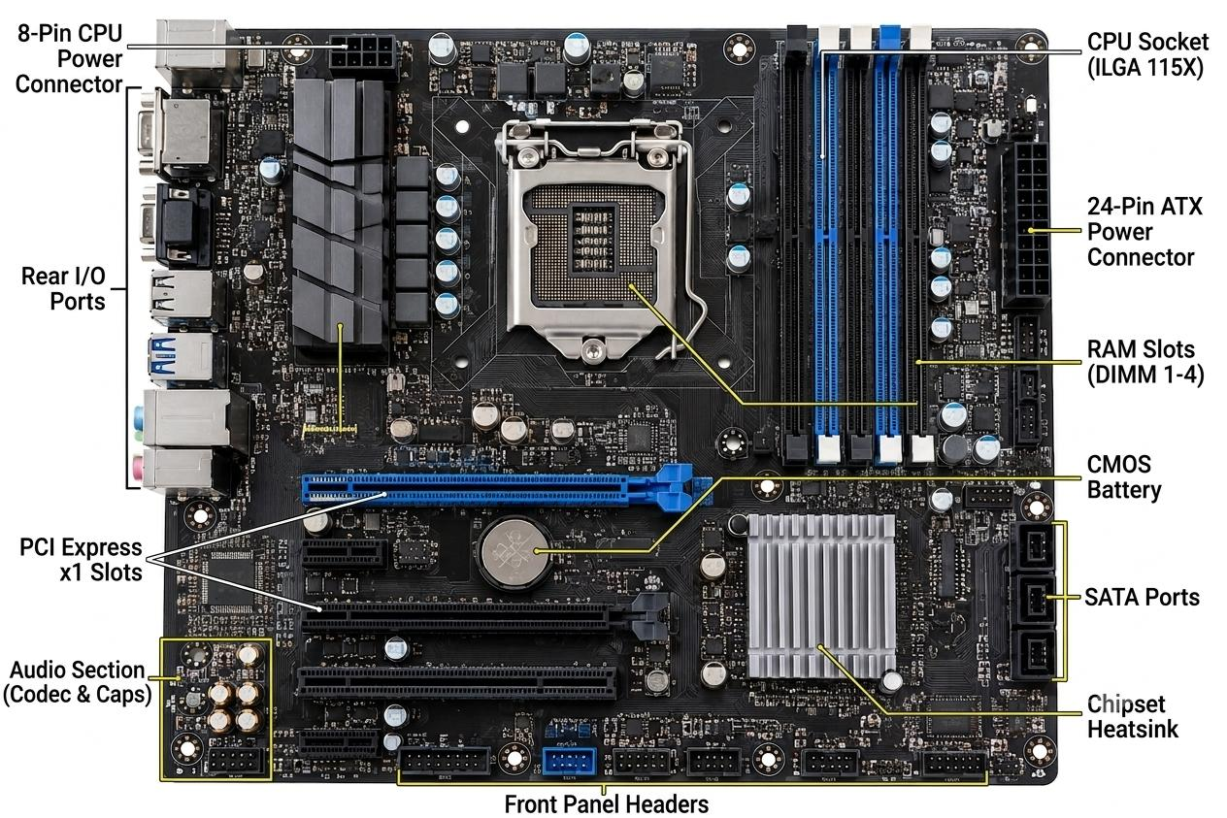
4. Real Motherboard Photo – Identification of Ports and Slots:

